Analyzing USGS Earthquake Data
Written by: Cazandra Aporbo
University of Denver
COMP 4448 | Data Science Tools 2
Instructor: Daniel Parada
March 2024

Abstract
This paper conducts an analysis of recent earthquake data to evaluate the effectiveness of machine learning models in predicting earthquake characteristics, such as magnitude. Web scraping techniques were employed on the USGS dataset, which includes earthquake records from the last 30 days.¹⁰ The analysis further applies machine learning and statistical techniques to uncover patterns related to earthquake occurrences, focusing on aspects like location, magnitude, and depth. The results suggest that identifiable patterns within the data could aid in forecasting the magnitudes and locations of future earthquakes, potentially enhancing disaster preparedness and risk management strategies. ¹⁵ Additionally, this investigation supports the objectives of the Collaboratory for the Study of Earthquake Predictability (CSEP) by using advanced analytics and publicly available data to deepen our comprehension of seismic activities and their possible consequences.¹²

Introduction
The challenge in accurately predicting the location of earthquake has been a scientific question yet to be answered. The Collaboratory for the Study of Earthquake Predictability (CSEP) plays a crucial role in coordinating a worldwide research initiative focused on improving our predictive understanding of seismic events.^{10, 12} By analyzing recent earthquake data from the USGS, this analysis contributes to the field of geological science by identifying patterns that may improve the understanding of earthquake predictors. Earthquake magnitude, quantified by the Richter scale or Moment Magnitude Scale, is a key metric for gauging the potential impact and severity of seismic occurrences. ¹ This research delves into the study of earthquake magnitudes along with other variables such as location and depth, aiming to shed light on the predictability of earthquakes.

Purpose of the Project
The primary objective is to utilize advanced data analysis techniques to explore the patterns of recent seismic activities and develop models capable of predicting earthquake occurrences and magnitudes. This project aims to contribute to the broader goals of earthquake science by improving risk assessment methods and aiding in the development better disaster readiness strategies.

Significance of the Project
The analysis of recent seismic events and the development of predictive models based on comprehensive data analysis are important in advancing the field of earthquake prediction and risk management. ^{10,15}

Research Question
Can machine learning models, using data on the locations, magnitudes, and depths of recent earthquakes, accurately predict earthquake magnitudes?

Description of the Dataset
The dataset from the USGS Earthquake Hazards Program includes key information on global seismic events from the past month, focusing on attributes such as time, location, magnitude, and depth, which are hypothesized to influence earthquake patterns and magnitudes.^{10, 12}

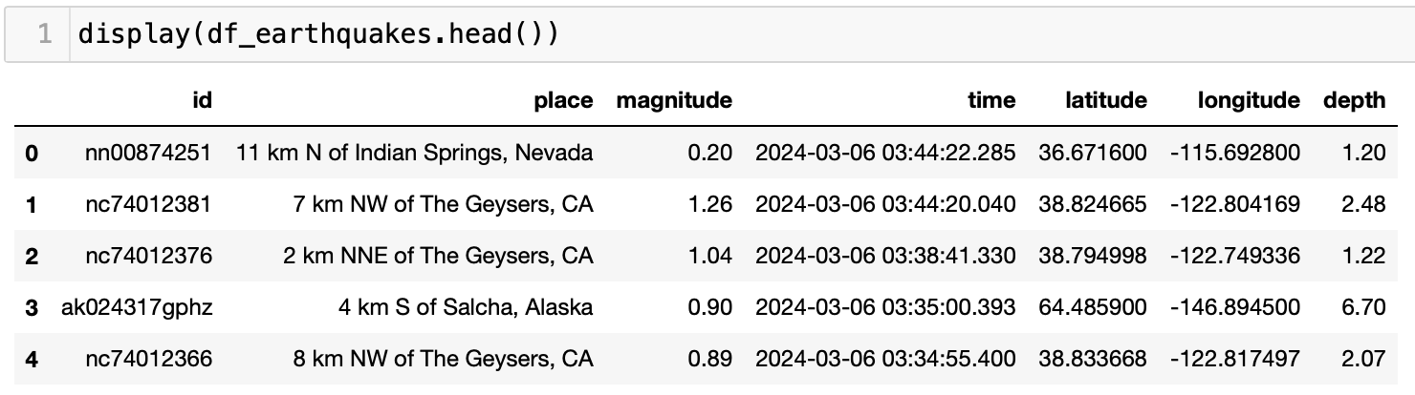

Data Preprocessing & Handling Missing Values
The dataset was cleaned and structured, with missing values in critical fields including 'magnitude' addressed through median imputation to maintain data integrity. ^{10, 13} Irrelevant columns were removed, and crucial variables were extracted or transformed to focus the analysis on predicting earthquake magnitudes and understanding seismic patterns, predominantly in regions like California where seismic activity is prevalent.

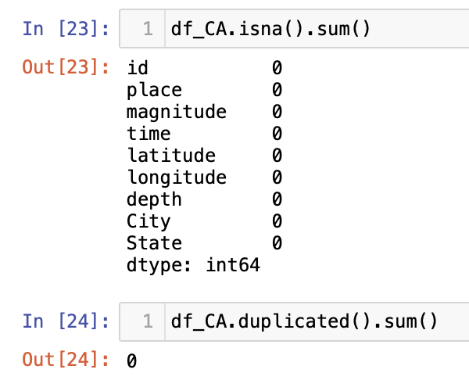

Exploratory Data Analysis
The initial analyses involved visualizing the distribution of earthquake magnitudes and depths, as well as their geographical locations, using interactive maps and histograms. This helped in identifying outliers and understanding the general patterns of seismic activity.

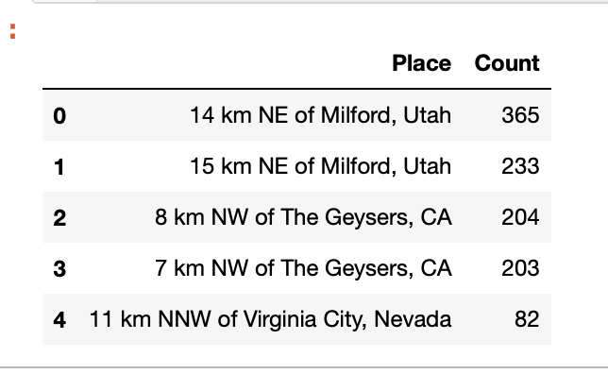
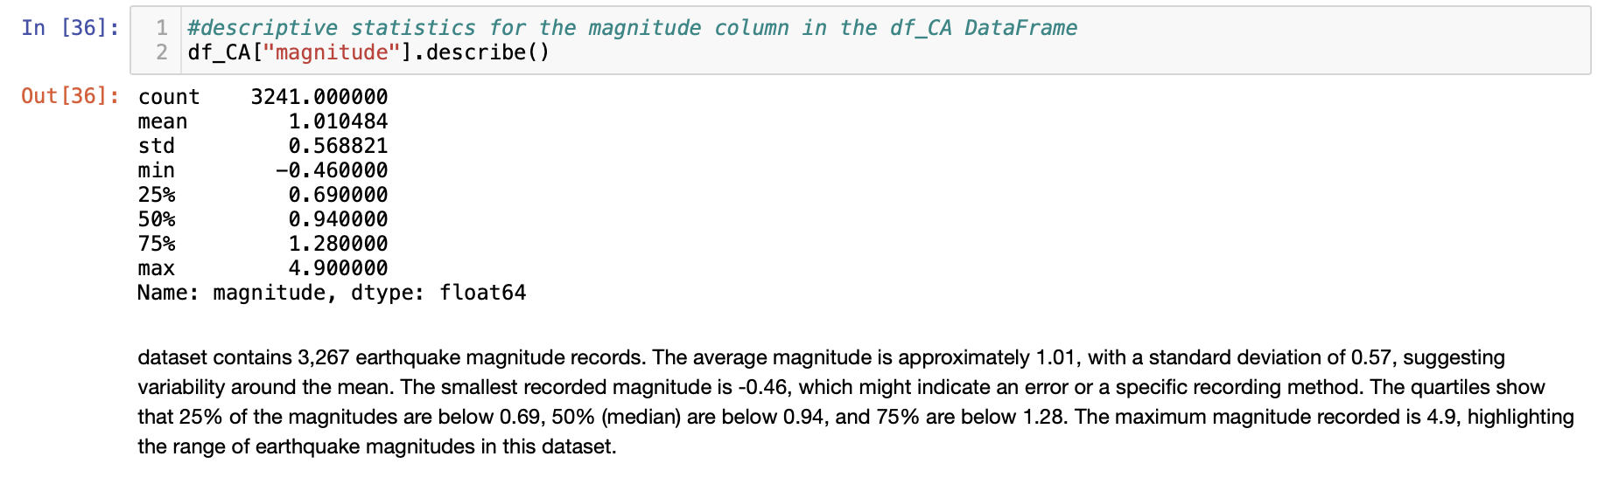

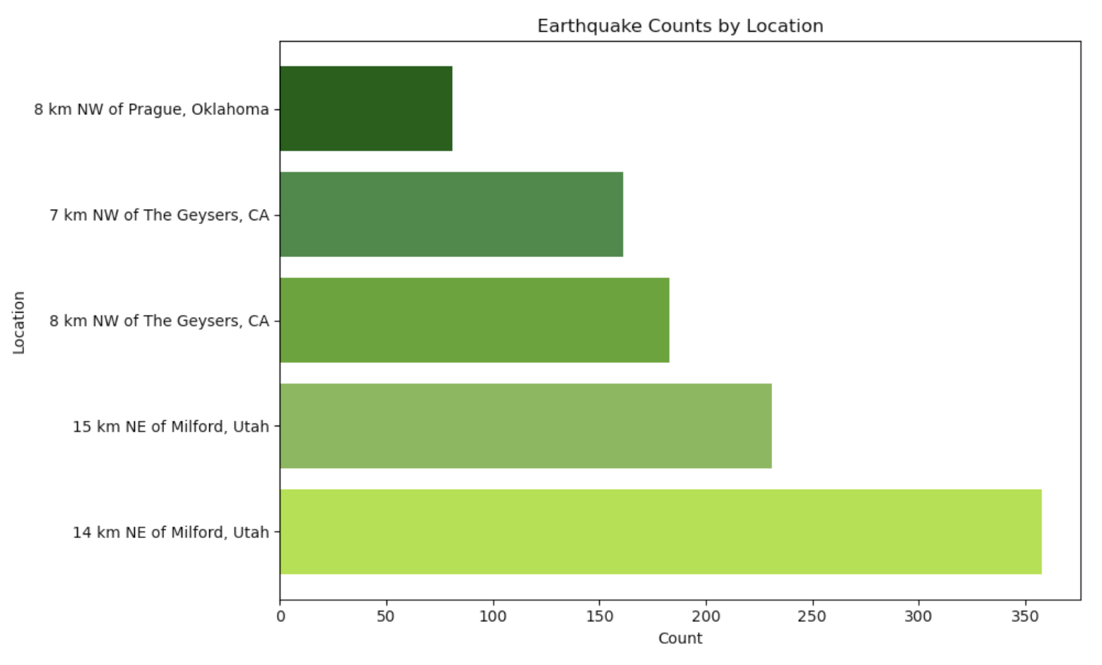

Bar Graph: of earthquake by location. Prior to parsing the place column and isolating location by city and state.

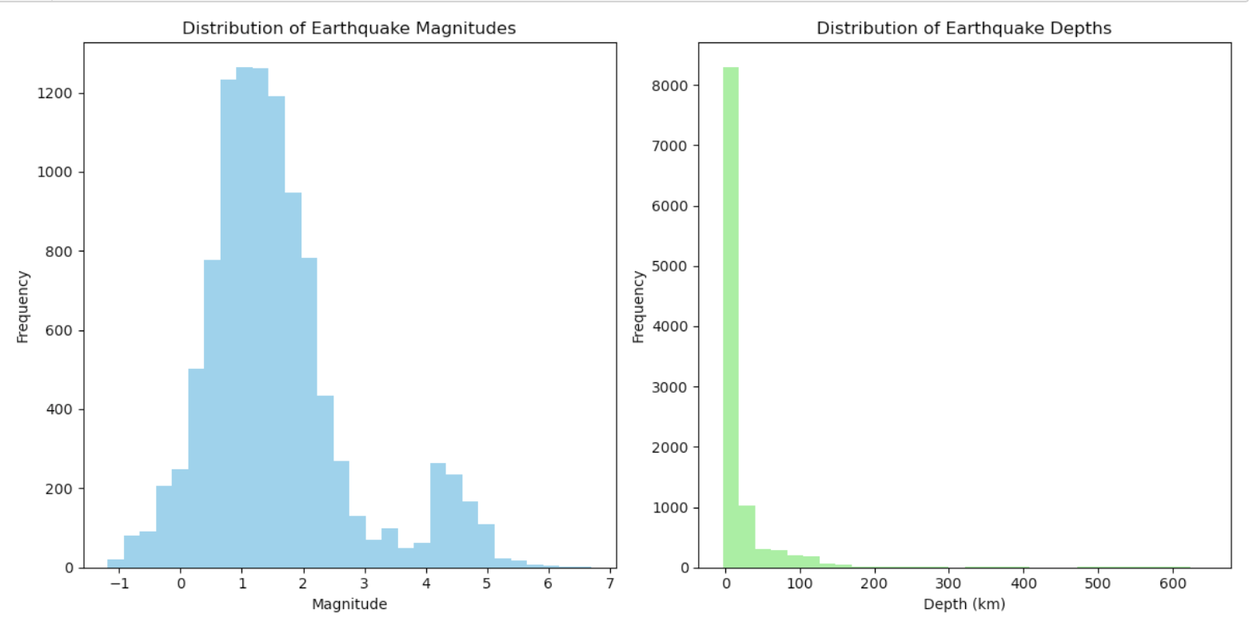

The first subplot visualizes the distribution of earthquake magnitudes. The second subplot focuses on the distribution of earthquake depths.

The histogram of magnitudes assesses the frequency of earthquakes at different magnitude levels. This visualization helps pinpoint the most common magnitudes for earthquakes and observe the tail of the distribution, which represents larger, less frequent events.

Like the magnitude distribution, the histogram of depths allows the assessment of how deep earthquakes typically occur and the variability in these depths. Understanding depth distribution is important as it relates to the possible impact of earthquakes and their detectability.

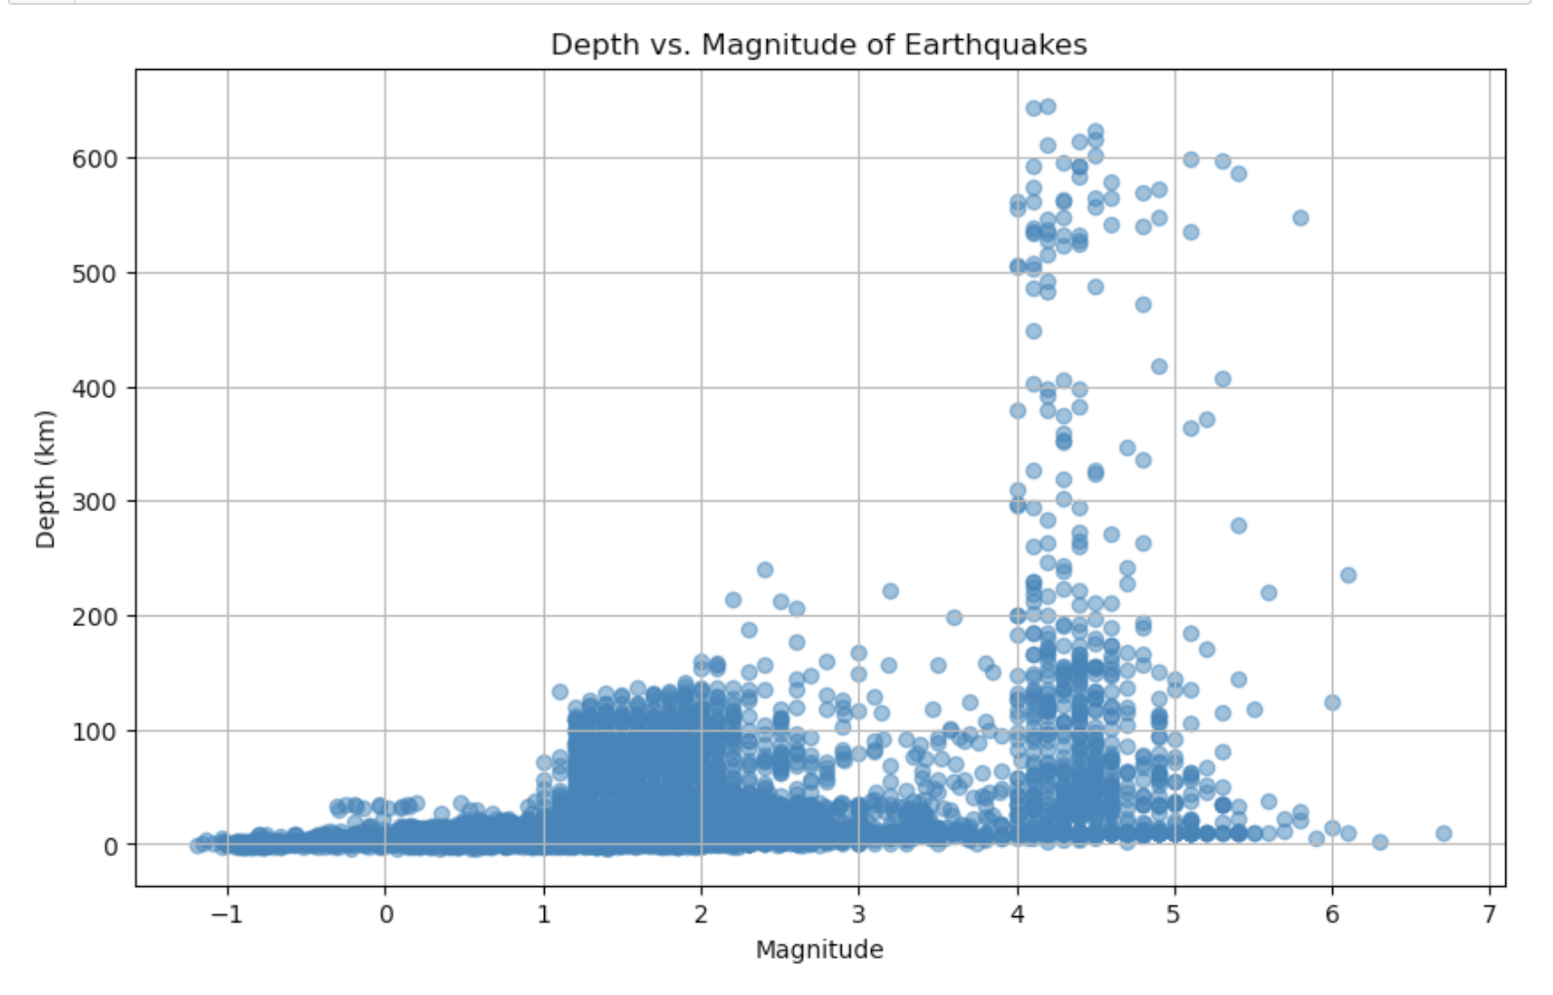
A scatter plot of Depth vs. Magnitude for earthquakes; can help identify any outliers in the data.

The analysis employs a scatter plot to visualize the relationship between earthquake magnitudes and depths, and to explore potential unseen correlations. By plotting magnitude on the x-axis and depth on the y-axis, trends can be detected, such as whether there's a predisposition for deeper earthquakes to exhibit higher or lower magnitudes.

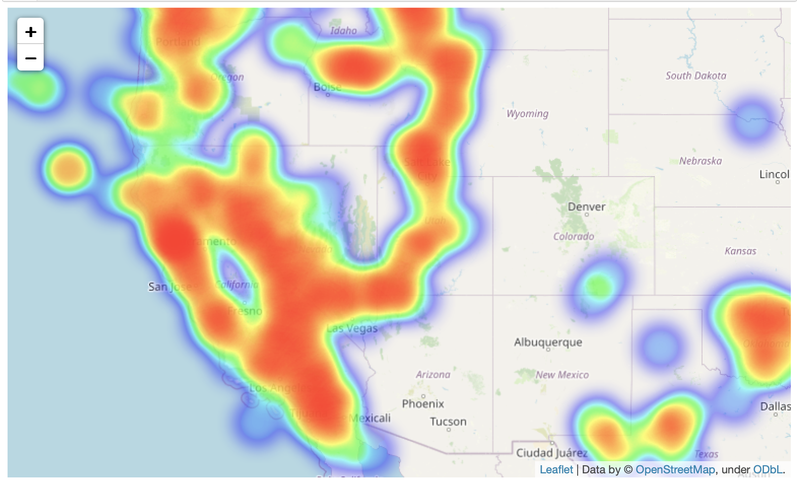

A visual representation of earthquake locations using the GeoPandas library.

To ensure the focus remains on the spatial distribution of these seismic events, the axis, including ticks and labels, was removed from the visualization.¹ This was completed through the ax.set_axis_off() command, rand resulted in a map that is easy to interpret and highlights only the earthquake locations. ¹ This visualization may be useful in discerning patterns in the distribution of earthquakes, such as areas of high seismic activity or unique geographical alignments.

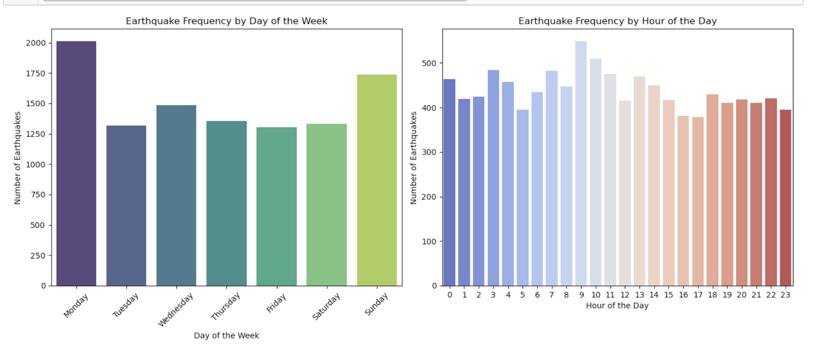

The transformation of the 'time' column in the df_earthquakes DataFrame into a datetime format, coupled with the derivation of 'day_of_week' and 'hour_of_the_day' columns, allowed analysis of earthquake frequency by day of the week and frequency by hour of the day.

The creation of a 'day_of_week' column and visualization help identify if earthquakes are more frequent on certain days of the week. While it might not be expected, the analysis reveals unexpected patterns or biases in the data, perhaps related to human activities or data recording practices. Also, by analyzing earthquake frequency by the hour of the day, the analysis exposes additional patterns in the timing of earthquakes. This may potentially divulge peak times for earthquake occurrences or periods that are relative calm.

Data Splitting
For machine learning analysis, the data was divided into training and testing sets after ensuring the data was clean and structured appropriately. This separation allows for the validation of the predictive models against unseen data.

Model Building and Evaluation
To generate a model capable of predicting earthquake magnitudes, the initial model (Model 1) was created as a RandomForestRegressor model. Which aimed to predict a continuous variable, namely the earthquake magnitude. Results of the regression model suggested that the regression model was not the best model to predict due to the R2 value being far from 1. For clarity, RandomForestRegressor and RandomForestClassifier are both ensemble learning methods based on decision trees, that are part of the scikit-learn library in Python that solve different types of prediction problems. ^{7, 14} RandomForestRegressor is used for regression tasks, where the goal is to predict a continuous quantity and the output is continuous values.¹⁴ Whereas, RandomForestClassifier is used for classification tasks, where the goal is to predict which category or class the target variable belongs to and the output is discrete labels. ^{7, 14}

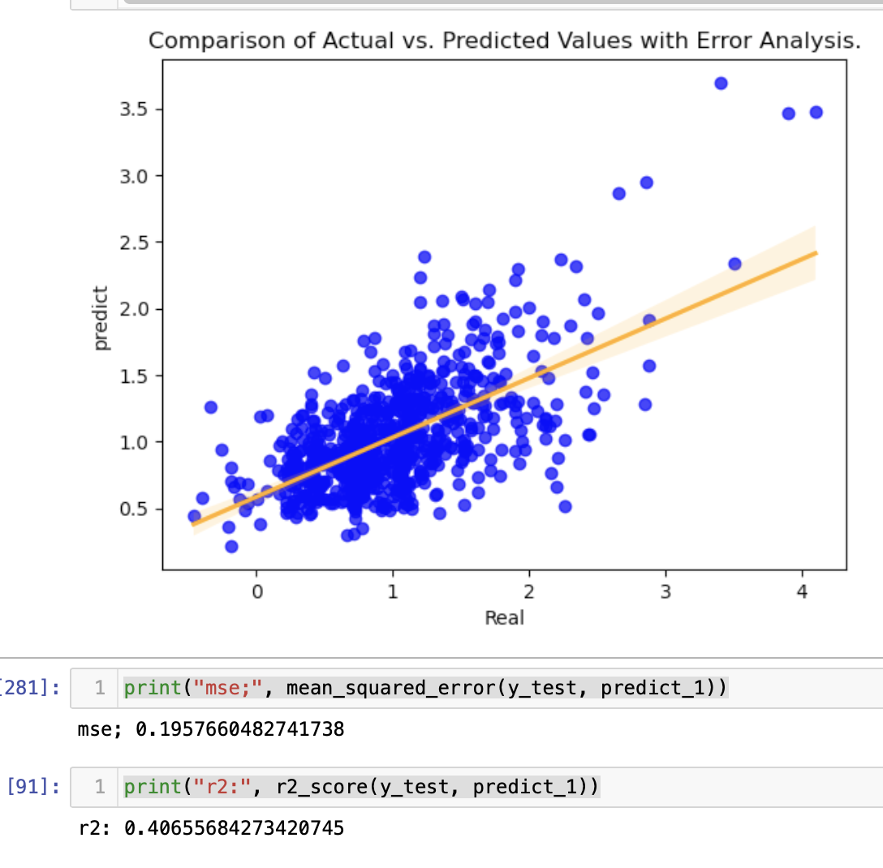
Model 1: Random Forest Regressor

Model Selection
Various predictive models were evaluated for their suitability in forecasting earthquake magnitudes based on historical data. However, after observed results from Model 1; RandomForestClassifier approach was employed on the df_CA dataset to distinguish between significant and non-significant earthquakes. Earthquakes with magnitudes equal to or exceeding 2 were marked as "Yes" in the newly created Response column, and those with lower magnitudes were labeled as "No". The classifier, although simple, was trained using geographical features including latitude, longitude, and depth. It resulted with a high accuracy score of approximately 0.949, which further indicates a high level of predictive accuracy.
A detailed examination through the confusion matrix and classification report provided more information on specific aspects of the model's predictive performance:

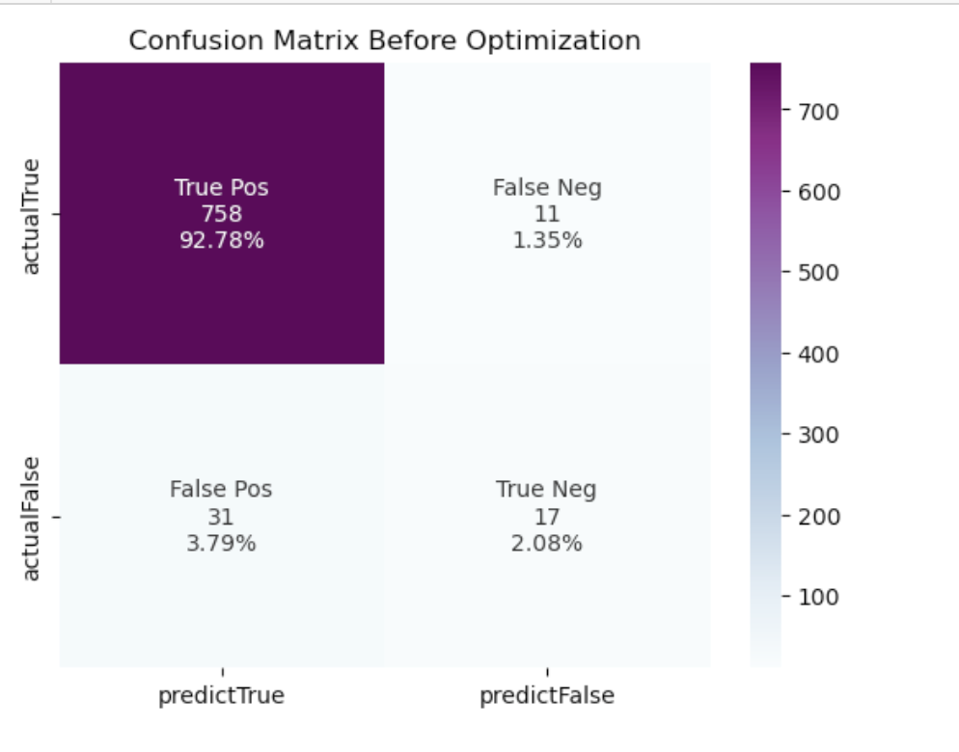
Model 2: Confusion Matrix results.

The confusion matrix recorded 758 true positives, accurately identifying significant earthquakes, and 17 true negatives for correctly spotting non-significant ones. However, there were instances of misclassification, with 11 false negatives and 31 false positives.
According to the classification report, the model demonstrated high precision and recall for the "No" class, proving its efficacy in pinpointing earthquakes below magnitude 2. However, the model encountered difficulties with the "Yes" class, evidenced by lower precision and recall rates, and a modest F1-score, indicating a need for improvement in accurately identifying significant earthquakes.

Model Optimization and Selection
Hyperparameter tuning was conducted to optimize each model's performance, utilizing techniques like grid search and cross-validation to identify the optimal configurations.
In the analysis, the grid_space variable plays a crucial role in fine-tuning the parameters of a RandomForestClassifier through GridSearchCV. ^{7, 14}This approach explores a range of values for n_estimators, max_depth, and min_samples_split to enhance model accuracy. Specifically, it looks at a fixed number of trees (100), varying depths of trees, and differing minimum samples for node splitting, allowing for a comprehensive assessment of parameter impacts on model performance. ^{7, 14}
The application of GridSearchCV, enables the precise training of the model on subsets of the data, X_train_2 and y_train_2, and identifies the optimal parameters that enhance prediction accuracy. The optimal parameters identified—max_depth of 5, min_samples_split of 2, and 100 estimators—inform the configuration of an improved model, model_opt, which is subsequently evaluated for its predictive accuracy.

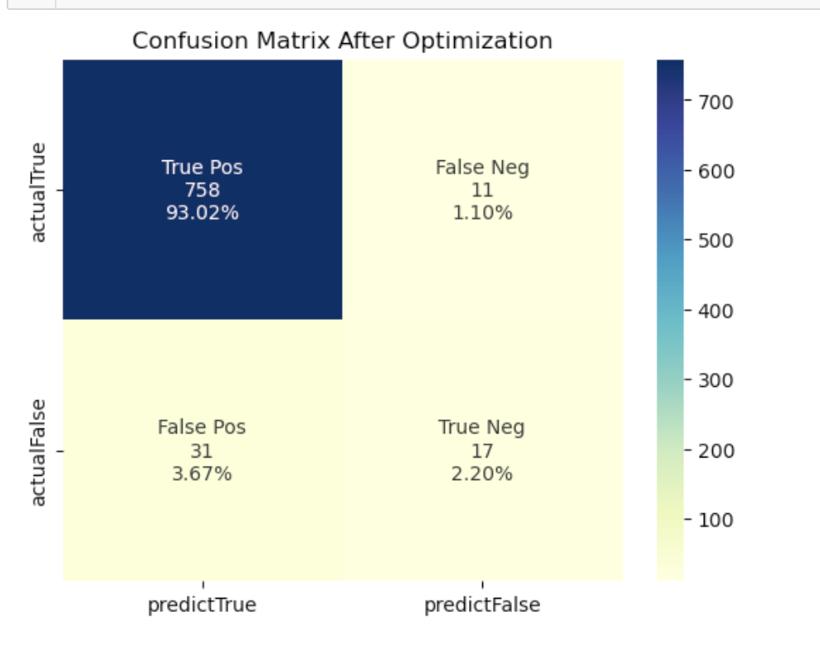

The optimized model demonstrates a marked improvement in classification accuracy, as evidenced by a comparison of confusion matrices before and after optimization. The refined model shows enhanced capability in correctly identifying positive and negative cases, an essential aspect for the practical utility of our research in earthquake prediction and risk assessment. ^{13,14}
This iterative process of parameter tuning, and model optimization underscores the importance of hyperparameter exploration in developing robust predictive models. ^{7, 14} By employing cross-validation, the analysis ensures a more reliable assessment of model performance, ultimately leading to a model that is accurate and generalizable.

Model Comparison
The models were compared based on their predictive accuracy and other relevant metrics, facilitating the selection of the most effective model for earthquake prediction.

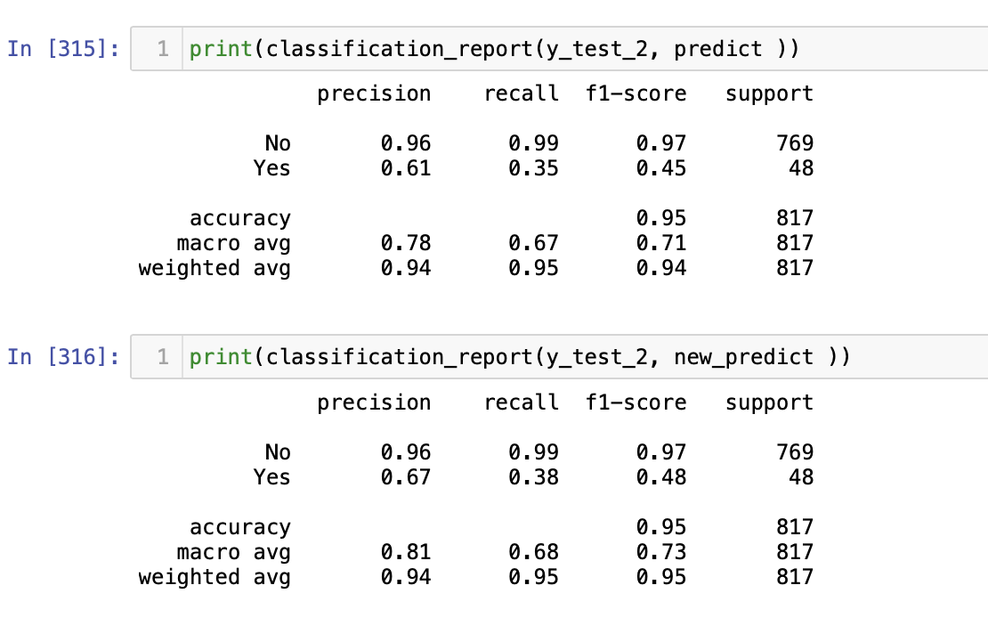

Conclusion
This research employed machine learning and statistical methods to improve the prediction of seismic events. The findings underscore the utility of historical data in forecasting earthquake magnitudes to a certain degree. ¹⁵ Despite the challenge of achieving highly accurate predictions, the study offers insights into the factors influencing earthquakes with magnitudes less than 2. The complexity of measuring earthquake magnitude—through methods such as wave amplitude, fault size, amount of slip, and scales like the Richter scale and the Moment Magnitude scale—highlights the need for a deeper understanding of these metrics to better interpret the dataset. ^{1, 15} The analysis has delved into earthquake data to uncover patterns that could lead to precise predictions of earthquake magnitudes.^{1, 10, 12,15} It emphasizes the importance of thorough data preprocessing, as well as the careful selection and calibration of predictive models, in the pursuit to accurately forecast spontaneous natural phenomena such as earthquakes.^{1, 15} The research also points to the inherent complexity of predicting earthquakes accurately. Future studies are encouraged to investigate more advanced models and to include additional factors that may affect earthquake occurrences, such as geological and environmental conditions. Collaborating with seismologists and data scientists could further improve the predictive accuracy and practical utility of this research.

Citations

- Al Jazeera. (2023, February 9). *Why is it so hard to predict earthquakes?* Al Jazeera. [https://www.aljazeera.com/features/2023/2/9/holdexplainer-how-do-earthquakes-happen

- Contextily: Background tiles in Python. (n.d.). Retrieved March 5, 2024, from [https://contextily.readthedocs.io](https://contextily.readthedocs.io)

- Folium. (n.d.). Retrieved March 5, 2024, from [https://python-visualization.github.io/folium/](https://python-visualization.github.io/folium/)

- GeoPandas: Python tools for geographic data. (n.d.). Retrieved March 5, 2024, from [http://geopandas.org](http://geopandas.org)

- Harris, C. R., Millman, K. J., van der Walt, S. J., Gommers, R., Virtanen, P., Cournapeau, D., ... & Oliphant, T. E. (2020). Array programming with NumPy. *Nature*, 585(7825), 357-362. Retrieved from [https://numpy.org](https://numpy.org)

- Hunter, J. D. (2007). Matplotlib: A 2D graphics environment. *Computing in Science & Engineering*, 9(3), 90-95. Retrieved March 5, 2024, from [https://matplotlib.org](https://matplotlib.org)

- McKinney, W., & others. (n.d.). pandas: Python Data Analysis Library. Retrieved March 5, 2024, from [https://pandas.pydata.org](https://pandas.pydata.org)

- Pedregosa, F., Varoquaux, G., Gramfort, A., Michel, V., Thirion, B., Grisel, O., ... & Duchesnay, E. (2011). Scikit-learn: Machine learning in Python. *Journal of Machine Learning Research*, 12(Oct), 2825-2830. Retrieved March 5, 2024, from [https://scikit-learn.org](https://scikit-learn.org)

- Requests. (n.d.). Retrieved March 5, 2024, from [https://requests.readthedocs.io](https://requests.readthedocs.io)

- United States Geological Survey. (2024). *Real-time, worldwide earthquake list for the past 30 days*. Retrieved from https://earthquake.usgs.gov/earthquakes/feed/v1.0/csv.php

- Waskom, M. (2024). seaborn: statistical data visualization. Retrieved March 5, 2024, from [https://seaborn.pydata.org](https://seaborn.pydata.org)

- Collaboratory for the Study of Earthquake Predictability (CSEP). (n.d.). Retrieved from https://cseptesting.org

- GeeksforGeeks. (2024) Replacing missing values using pandas in Python. Retrieved from https://www.geeksforgeeks.org/replacing-missing-values-using-pandas-in-python/

- GeeksforGeeks. (2024). Random Forest Regression in Python. Retrieved from https://www.geeksforgeeks.org/random-forest-regression-in-python/

- Caltech Science Exchange. (2024). Earthquakes. Retrieved from https://scienceexchange.caltech.edu/topics/earthquakes

